Table of Contents
No table of contents entries found.

Body fat
Body fat, or adipose tissue, is a complex organ. It contains fat cells, nerves, immune cells, and connective tissue. Its main job is to store and release energy, depending on the body’s needs.
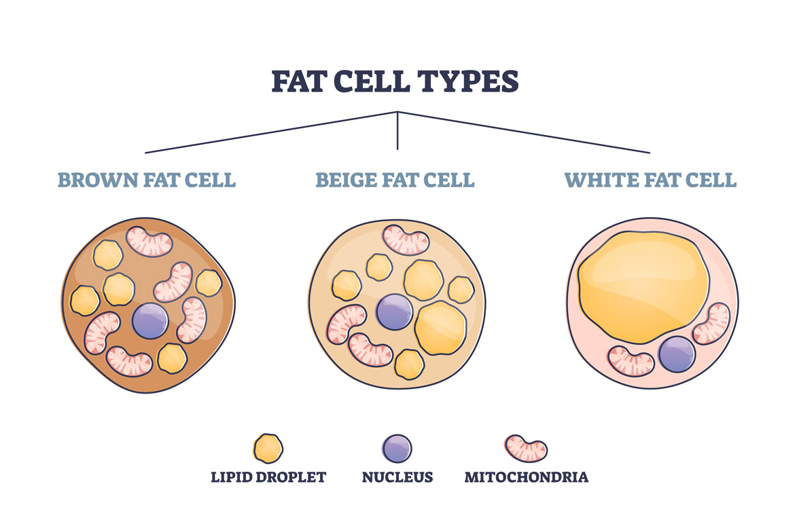
Figure 1 three types of fat cell.

 | White Fat | Brown Fat | Beige (Yellow) Fat
Location  (Visceral fat and Subcutaneous fat) | • Subcutaneous  • Intra-abdominal  • Epicardial  • Gonadal | • Interscapular  • Paravertebral  • Perirenal  • Cervical  • Supraclavicular | Emerges in white adipose tissue depots with  appropriate stimuli
Morphology | Spherical | Elliptical and smaller than white | Spherical
Function  (While all fat cells might look alike from the outside, they can have different functions, depending on their type. There are three main types of fat cells. Researchers are studying whether they can harness the positive traits of brown and beige fat and use them to treat obesity.) | These are the body’s main type of fat cells. They store energy and produce hormones like leptin and adiponectin. They are largely found in the chest, belly, and legs. | What’s unique about brown, or thermogenic, fat is that it burns energy and produces heat (non-  shivering thermogenesis) in certain conditions, like cold weather. People with more brown fat tend to be leaner and healthier, compared to those with less brown fat. Studies show that brown fat improves metabolism and reduces the risk of diseases like type 2 diabetes, coronary artery disease, and high blood pressure. It’s found in the neck, upper chest, shoulder, and stomach. | In some cases, white fat transforms into “beige” or “brite” fat cells. Like brown fat, it burns energy to produce heat.
Precursor/progenitor | CD24⁺, CD34⁺, PDGFR⍺⁺ | Vascular smooth muscle origin | Myogenic origin  Pax7⁺, En-1⁺, Myf5⁺
Uncoupling protein | Undetectable | Positive | Positive after stimulation
Table 1 the basic infor. about the fat, CD, cluster of differentiation; En-1, Engrailed-1; Myf5, myogenic factor 5; Pax7, paired box 7; PDGFRα. platelet-derived growth factor receptor alpha; PVAT, perivascular adipose tissue; and Ucp-1, uncoupling protein-14.
Some views:
- BAT (Brown adipose tissue) is recruited to counteract incipient “preprediabetic” states, potentially serving as a first-line protective mechanism against very early metabolic or hormonal variations

“The healthy adipose tissue”
Hormones produced by adipose tissue regulate metabolism and insulin sensitivity. They help the body use nutrients efficiently.

Muscle development

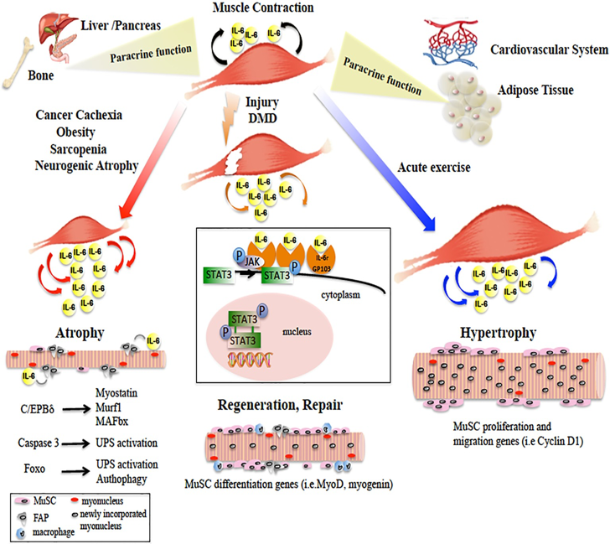Figure
Jak/STAT3 pathway:
(Pax7-) Satellite cell expansion MyoD1 upregulate promote myogenic lineage progression.
(Pax7-) Satellite cell expansion regenerating myofibers tissue repair
(Pax7+) Satellite cell differentiation fiber sturcture mature

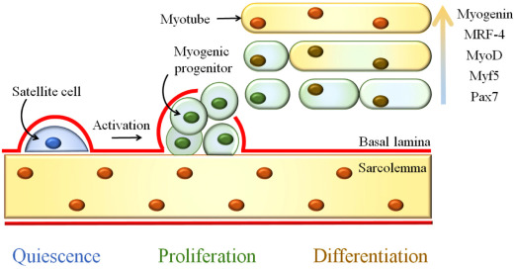
Figure Differentiation of muscular SCs from the satellite cell that leaves its quiescence and produces myoblasts that differentiate into polynucleate and fused muscle fibers. For a color version of this figure, see www.iste.co.uk/arrighi/stemcells.zip
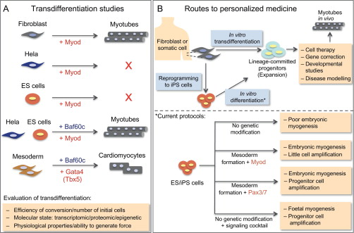
Figure Myogenic conversion and routes to personalized medicine. (A) The hallmark of the reprogramming era began with the transdifferentiation of multiple cell types to skeletal myogenesis and cell-fate conversion with Myod(Davis et al., 1987). Some cells remained refractory to myogenic conversion (HeLa, ES cells) (Albini et al., 2013; Dekel, Magal, Pearson-White, Emerson, &amp; Shani, 1992; Weintraub et al., 1989). More recently, chromatin modifiers (e.g., Baf60c) were found to render some of these cells permissive to conversion (Albini et al., 2013; Forcales et al., 2012; Takeuchi &amp; Bruneau, 2009). This underscores the notion that rendering the chromatin accessible should be considered in concert with the choice of transcription factor(s) for directing the desired cell fate. In addition, a combination of parameters should be routinely evaluated to assure full cell-fate conversion. (B) Schematic representation of some of the approaches under investigation to produce new muscle tissue for therapeutic use (upper panel). Patient fibroblasts can be directed to transdifferentiate in vitro into lineage-committed myogenic cells directly or via a reprogramming step through iPS cells. The generation of lineage-committed progenitors has a number of advantages: reduced chance of teratoma formation, minimization of alternative cell fates and ideally, the potential to specifically generate the desired type of muscle progenitors (location specific, slow vs. fast fibers). The conversion of pluripotent ES or iPS cells to myogenesis has been a major obstacle (lower panel). Although different strategies have now made it possible to amplify skeletal muscle stem/progenitor cells, this is achieved by genetic manipulation of the ES/iPS cells. Furthermore, fetal/adult myogenesis has not been systematically generated in these in vitro differentiation.

Members of the MyoD family of basic helix-loop-helix (bHLH) proteins—MyoD, Myf5, myogenin, and MRF4 —act at multiple steps in the myogenic pathway to control the establishment of the myogenic lineage and the activation of differentiation genes

What You Need to Know About Body Fat
Food Ingredients Involved in White-to-Brown Adipose Tissue Conversion and in Calorie Burning
The Role of the Gut Microbiome in Energy Balance With a Focus on the Gut-Adipose Tissue Axis
Obesity, Adipose Tissue and Vascular Dysfunction
Brown adipose tissue: a protective mechanism in “pre-prediabetes”?
STAT3 signaling controls satellite cell expansion and skeletal muscle repair

